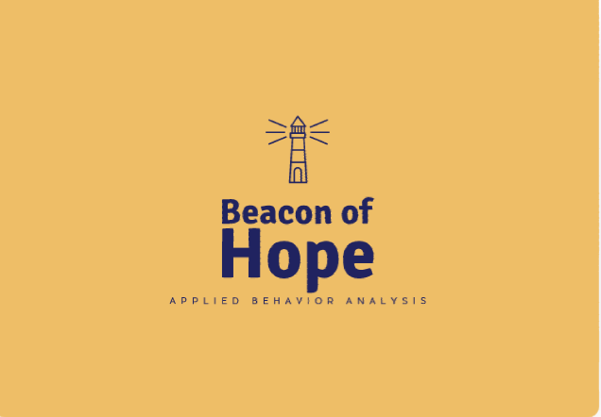Beacon of Hope ABA and Behavioral Consultation

BeaconofHopeABA@gmail.com

Request Beacon Services

Client Name: |  | Client Gender: | Male ☐ Female ☐
Date of Birth: |  | Client’s Age:
Primary Address:
(Street, City, State, Zip Code)
Email Address:

Parent 1 Name: |  | Parent 1 Phone:
Parent 2 Name: |  | Parent 2 Phone:
OT | ☐ Yes ☐ No | Hours per week |  | At school?  ☐ Yes ☐ No
PT | ☐ Yes ☐ No | Hours per week |  | At school?  ☐ Yes ☐ No
Speech | ☐ Yes ☐ No | Hours per week |  | At school?  ☐ Yes ☐ No
Coordination of Care will be provided as requested by parents by email, fax, or phone with all concerned providers
Who does child live with? ☐ Mother ☐ Father ☐ Other __________________
Any cultural or spiritual preferences?
Number and Age of Siblings in Home:

Diagnostic Information:
☐ Private Pay ☐ Medicaid ☐ Other Insurance
Insurance Company Name

Policy# |  |  | Group #
Medicaid #
(If Applicable)
Tricare (DOD # or Social Security #

(Submit a Picture of Front and Back of insurance card with intake paperwork)

By clicking this box you are giving Beacon of Hope permission to use or disclose your protected health information (PHI) for treatment, payment and health care operations purposes.
If you are unable to upload an image, please check this box and we will get in touch with you to help.

Diagnostic Information:

Referring Physician: |  | Date of Referral:
Mental Health Diagnosis: | ☐ ASD ☐ Other (for ABA):
Who diagnosed? |  |  | Date Diagnosed:
Additional Diagnoses:
Primary Physician:

Medications:
Medication | Dosage | Symptom targeted by medication

Food or Drug Allergies: ☐ Yes ☐ No
Specific Allergen | Physical Reaction | Effect on Behavior | Does reaction require immediate medical attention (i.e. epi pen or other)?

(Send in the initial diagnostic report with intake forms)

What Behaviors are you most concerned about reducing (i.e. tantrums, self-injury, aggression, non-verbal, etc)?

Checklist for Authorization

As soon as we receive your intake info, we will start working on the insurance authorization. Once that is received, we will meet with you and your child to complete an assessment and write a behavior plan. The insurance company will approve the behavior plan and then we start the therapy!

Please call: (334) 477-4686 if you have any questions.

☐ Initial Diagnostic Report (this is the official diagnosis document)
☐ Prescription for BAS Therapy
☐ Front and Back of Insurance Card
☐ Request for Beacon of Hope Services Form
☐ Assignment of Benefits and HIPAA Form

